CADANGAN WAKIL PENYERTAAN UiTM SABAH
NO. | CATEGORY | GROUP MEMBER
CATEGORY MO: UNIVERSITIES (DEGREE AND UPWARDS)
KATEGORI A : STAFF
01. | Landslide Risk Navigation Along Road (LaRiNav) | Hamjah Rusli
CATEGORY MO: UNIVERSITIES (DEGREE AND UPWARDS)
KATEGORI A : STAFF
01. | Wing Patterns Guide To Lepidopterans | Hazmi Awang Damit,Mohd Hafezan Sisa
02. | Kamus Abqarie Online:Kamus Melayu-Arab-Inggeris | Ustaz Mazuki Izani Ismail
CATEGORY Y (YOUNG INVENTORS) : COLLEGES (DIPLOMA)
KATEGORI B : STAFF
01. | Multipurpose Gardening Tools Handle | Noorsidek Dali,Ahmadie Hassan
02. | Power Jek Auto | Suzlley Matawali, Suhaimi Abd Gapar
03. | ATROM’s (Advance Tyre Remover Machine) | Suzlley Matawali
CATEGORY Y (YOUNG INVENTORS) : COLLEGES (DIPLOMA)
YOUNG IID: KATEGORI A
01. | Dillenia Suffruticosa, A High Potential Commercial Value | Sheenie Paskalina
CATEGORY Y (YOUNG INVENTORS) : COLLEGES (DIPLOMA)
KATEGORI B : YOUNG IID
01. | Cyclo Electric Generator (Cy-E-G) | Mohd Azril bin Hamdin, Norazwan bin Bastari

CATEGORY MM: UNIVERSITIES (DEGREE AND UPWARDS)
KATEGORI B : STAFF
NO.2 Landslide Risk Navigation Along Road (LaRiNav)

Project Leader : HAMJAH B. RUSLI

What problem does it solve?
1. This product would help road users in planning their safe journey.
2. Assisting government and local authority to plan preventive measures and landslide disaster management.
Is your innovation patented, copyrighted, published in a technical journal or otherwise noted with any recognized arbiters of innovation?
Applied for patent and copyright protection in Malaysia on 12 may 2010, and it is under “ 2xxx Universiti Teknologi MARA (UiTM) All rights reserved”

How is your innovation different from what already exists? What competition does it face?
LARINAV is an integrated tool consist of five(5) products shows the level of landslide risk along road;

i) Map risk version
ii) Book Template
iii) Video simple version
iv) Video full version
v) GPS navigator version

How will your innovation improve quality of life, enhance efficiency or productivity, or protect the environment?
It is an integrated landslide risk warning tools. It is easy to use and understand thus help road user in planning their journey, as well as professionals may find it useful to plan and take necessary action to take preventive action to avoid landslide occurrences.

Has it achieved any measurable results to date?
i) Gold Medal Award at Invention, Innovation and Design (IID) 2010 (12 – 14 January 2010) at Universiti Teknologi MARA, Malaysia.
ii) Participate in International Invention, Innovation & Technology Exhibition (ITEX) 2010 on 14-16 may 2010 held at KLCC, Kuala Lumpur MALAYSIA
iii) Silver Medal Award at Malaysia Technology Expo (MTE) 2011 on 17 – 19 February 2011 held at KLCC, Kulau Lumpur MALAYSIA

Does it address a new or an existing market? How big do you expect that market to be in the next year?
It is a tools with new concept that serve people at all level.

What are your future plans for this innovation?
1. To update information and expand the use of LARINAV for other roads in the country.
2. All risk information will be able to up load into GPS navigator.
SUPPORTING MATERIALS;

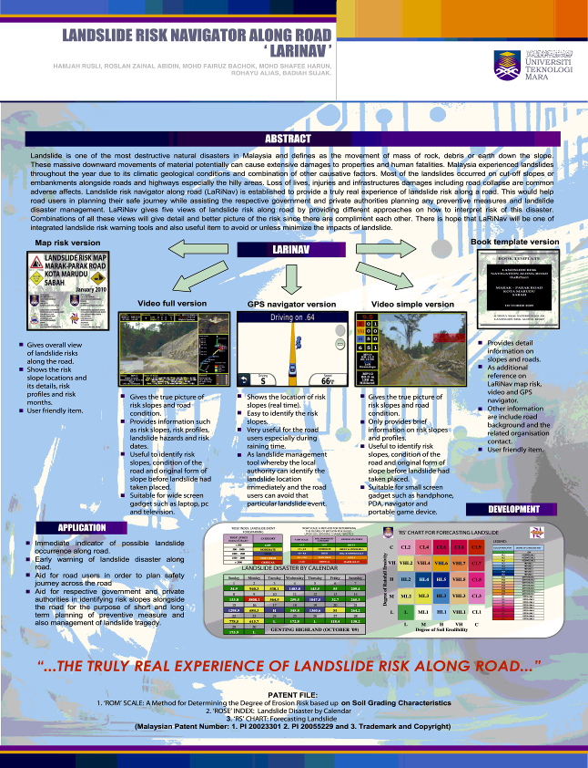
Briefly describe your business model.
Landslide Risk Navigator Along Road (LARINAV), is an integrated tool shows the level of landslide risk along road.
Have you achieved any commercial success to date?
This is relatively a new approach in which the idea to shows the finding obtained from research on landslide risk along the road in the state of Sabah, MALAYSIA using 5 integrated tools, and it is not been commercialized yet. Other achievement;
Internal and external achievement
i) Gold Medal Award at Invention, Innovation and Design (IID) 2010 (12 – 14 January 2010) at Universiti Teknologi MARA, Malaysia.
ii) Participate in International Invention, Innovation & Technology Exhibition (ITEX) 2010 on 14-16 may 2010 held at KLCC, Kuala Lumpur MALAYSIA
iii) Silver Medal Award at Malaysia Technology Expo (MTE) 2011 on 17 – 19 February 2011 held at KLCC, Kulau Lumpur MALAYSIA

What are the commercial prospects for your innovation?

There are 5 product integrated in LARINAV that can serve the need for every people / agency / government who might have the interest in safety protection and environment;
i) Map risk version
ii) Book Template
iii) Video simple version
iv) Video full version
v) GPS navigator version

CATEGORY MM: UNIVERSITIES (DEGREE AND UPWARDS)
STAF: KATEGORI A
No. 1 WING PATTERNS GUIDE TO LEPIDOPTERANS
Hazmi Awang Damit, Mohd Hafezan Sisa and Sabki Hj Suhaili,
Faculty of Plantation and Agrotechnology, Universiti Teknologi MARA Sabah
E-mail: hazmiad@sabah.uitm.edu.my

Lepidoptera is an order of insect that includes moths and butterflies. Members of the order are referred to as lepidopterans. The term Lepidoptera is derived from the ancient Greek word lipid, which means scale, and ptera (wing). It is one of the most speciose orders in the class Insecta, which include 19 families. However, the variation in the shape of wings and varieties of markings, spots and strips make identification of the species difficult. This manuscript is designed to alleviate that problem and can be handy for zoologists, entomologists, insectologists, lepidopteralists, and insect enthusiasts who need to make quick identification and labelling of lepidopterans by using their wing patterns. This manuscript provides a quick and easy reference for identification by using drawings and pictorial illustrations.

The achievement received by WING PATTERNS GUIDE TO LEPIDOPTERANS

Internal Competition

i) Gold Medal Award at MINI Invention, Innovation and Design (IID) 23 February 2011 at Universiti Teknologi MARA Cawangan Sabah

CATEGORY MM: UNIVERSITIES (DEGREE AND UPWARDS)
STAF: KATEGORI A
No.2 
KAMUS ABQARIE ONLINE: Kamus Melayu-Arab-Inggeris
Pernyataan Masalah

Berdasarkan carian penulis di enjin pencari Google dan Yahoo, sukar untuk menjumpai kamus atas talian daripada bahasa Melayu ke bahasa Arab. Kamus e-alQamus di URL http://alqamus.moe.edu.my/ealqamus/ merupakan antara kamus Arab-Melayu yang terbaik di internet. Ia menterjemah dari Arab ke Melayu. Meskipun begitu, pengguna boleh juga membuat carian menggunakan bahasa Melayu supaya diterjemahkan ke bahasa Arab melalui fungsi kotak carian yang disediakan. Kamus Indonesia-Arab-Indonesia di URL http://kamus.javakedaton.com/ juga agak menarik dan boleh juga dijadikan rujukan. Kamus Arab juga boleh diakses daripada Google Translator yang sering dijadikan rujukan oleh pelajar yang mengambil bahasa Arab.

Walau bagaimanapun kamus-kamus ini tidak memenuhi apa yang penulis ingin hasilkan pada Kamus Abqarie.

Kamus Abqarie

Abqarie (عبقري) adalah perkataan Arab yang bermaksud genius, pintar, bijaksana

Kamus ini bakal memberi kemudahan kepada pelayar terutama pelajar UiTM yang mengambil subjek bahasa Arab. Fokus ciri kelainan kamus ini berbanding kamus-kamus lain ialah aspek pernyataan kata kerja bahasa Arab. Kata kerja bahasa Arab memiliki ciri keistimewaan yang berlainan berbanding bahasa Melayu atau bahasa Inggeris. Satu kata kerja BM boleh diaplikasikan kepada mana-mana kata ganti diri tanpa apa-apa perubahan ke atas satu-satu kata-kerja. Dalam bahasa Arab, setiap kata kata kerja akan berubah bentuk dan sebutannya mengikut kata ganti diri yang digunakan. Kamus Abqarie akan memberi penekanan aspek ini kepada pengguna dalam penerbitannya yang tidak disentuh oleh kamus-kamus lain sama ada online ataupun offline. Kamus ini juga turut menyediakan terjemahan dalam bahasa Inggeris bagi membantu pengguna memahami satu-satu perkataan. Pengguna juga boleh membuat carian dalam samada Melayu-Arab, Arab-Melayu, Melayu-Inggeris, Inggeris-Melayu, Arab-Inggeris, atau Inggeris-Arab. Walau bagaimanapun, buat permulaan ini semua entri dalam kamus ini akan berdasarkan semua perkataan yang digunapakai dalam silibus bahasa Arab UiTM yang melibatkan 5 buah buku teks utama iaitu bagi kod BAB101/110, BAB151/120, BAB401, BAB451 dan BAB501. Entri-entri lain akan ditambah secara sedikit demi sedikit setiap hari bagi menjadikannya kamus Melayu-Arab-Inggeris online yang lengkap, insya-Allah.

The achievement received by KAMUS ABQARIE ONLINE

Internal Competition

i) Bronze Medal Award at MINI Invention, Innovation and Design (IID) 23 February 2011 at Universiti Teknologi MARA Cawangan Sabah
CATEGORY Y (YOUNG INVENTORS): COLLEGES (DIPLOMA)
STAF: KATEGORI B
No. 1 MULTIPURPOSE GARDENING TOOLS HANDLE
Unit Ladang DPIM
Universiti Teknologi MARA (UiTM) Sabah
Project Leader | Noorsidek Bin Dali @ Helmy
Technician | Ahmadie Hassan
Introduction
Unit ladang of UiTM Sabah Branch, under the Academic Affairs, has been involved actively in the training of the Diploma in Planting Industry students since the year 2000. Among the farm practicals organized by the unit are vegetable gardening, horticulture and landscape, and fruit farming. Beside farm machines and electrical tools, students use conventional gardening hand tools such hoes, spades, and trowels.
Problem Statement
The conventional tools, namely the hoe, the spade, and the trowel usually wear down and gets broken after some use. This is especially true when the brands are of the cheaper types. Most tool handles are made of non-heavy duty wood materials, making them prone to rotting and breakage. In addition, one type of handle can be fitted to only one type blade or accessory. As a result, once a wooden handle is broken, a new handle has to be bought. Moreover, these types of tools require more storage space. Students also have to bring different types of tools for different purposes to the farm.
Advantages/Usefulness
The Multipurpose Gardening Tools Handle is created to provide more flexibility (the handle can be fitted with many types of gardening tools), endurance, reduction in storage space, and long-term maintenance cost.

The achievement received by MULTIPURPOSE GARDENING TOOLS HANDLE

Internal Competition

i) Gold Medal Award at MINI Invention, Innovation and Design (IID) 23 February 2011 at Universiti Teknologi MARA Cawangan Sabah

CATEGORY Y (YOUNG INVENTORS): COLLEGES (DIPLOMA)
STAF: KATEGORI B
NO. 2 POWER JEK AUTO

Ketua Projek Suzzly Matawali
Ahli Projek Suhaimi Abd Gapar

POWER JEK AUTO direka khas untuk memudahkan kerja-kerja menjek kenderaan dimana ianya menggunakan kuasa elektrik kenderaan dengan mudah dan cepat serta boleh digunakan oleh semua pengguna kenderaan.

Ia boleh digunakan untuk kenderaan kecil sahaja dimana jek tersebut mempunyi motor untuk memusingkan jek tersebut dengan mudah, jek yang sedia ada di setiap kenderaan menggunakan system mekanikal memerlukan kerahan tenaga untuk memusingkanya. Dengan terhasilnya ciptaan ini, kerahan tenaga dapat dijimatkan dan sesuai untuk semua peringkat umur pemandu dan golongan wanita. Kos yang lebih effisien mudah dibawah dan berpotensi untuk dipasarkan ke seluruh Malaysia.

The achievement received by POWER JEK AUTO

Internal Competition

i) Silver Medal Award at MINI Invention, Innovation and Design (IID) 23 February 2011 at Universiti Teknologi MARA Cawangan Sabah

CATEGORY Y (YOUNG INVENTORS): COLLEGES (DIPLOMA)
STAF: KATEGORI B
NO.1 ATRoM’S (Advance Tyre Remover Machine)
Project Leader Mr. Suzley Matawali
ABSTRACT
Introduction
ATRoM’S stands for Advance Tyre Remover Machine invented by One Voice in 2009. This new machine was produced after considering major problems in assigning a task for drivers to change bus tyre in UiTM Sabah. Therefore, One Voice managed to create one small machine which is more effective, efficient and take lesser time and energy to change UiTM Sabah’s bus tyres.
Problem Statement
There are several major factors being considered faced by UiTM Sabah when it’s come to change tyre for UiTM Buses. There are:
1. By using the normal way, drivers have to use a 7.5 feet long pipe, T extension (60mm) and extension box (44mm) to change the tyre as required.
2. This method requires more than 4 persons to change a tyre and it takes about 129 minutes to change tyre.
3. The drivers need to have bigger space to change the tyre by using the old method.
4. After all the nuts are opened, tyres are removed the tyres from housing break and it needs more than 2 persons to lift it up and replace with a spare tyre into the housing break.
5. Tyres nuts are tightening using the same method to open them previously.
Advantages/Usefulness
One voice decided to invent a new machine called ATRoM’s (Advance Tyre Remover Machine) to open the tyre more easily, there is no need to acquire more people to open and lift the tyre. When designing ATRoM’s, less energy consumption and safety factors were considered. This invention also have advantages in terms of:
1. | Able to be used by all divisions or departments that provide transportation service.
2. | The normal method takes 129 minutes to change only 1 tyre. By using ATRoM’s the time feeded was reduced to only 36 Minutes.
3. | Reduce the tyres (expenditure), increase the life time cycle for tyres by using the optimum usage for all tyres.
4. | Reduce the injury risk and guaranteed the health of drivers when using the ATROM’s to change or remove the tyre.
5. | ATRoM’s can easily be bought inside the bus, and used at anytime and every where.
6. | All programs, internal or external activities, runs smoothly.
7. | Green technology and can be considered as friendly environmet machine.
8. | Increase the divers’s confident level and satifaction through the usage of ATRoM’s.
SUPPORTING MATERIALS;
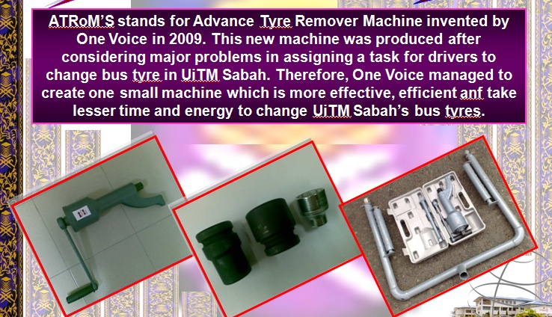

The achievement received by ATRoM’S
Internal and external achievement
i) Gold Medal Award at Invention, Innovation and Design (IID) 2010 (12 – 14 October 2010) at Universiti Teknologi MARA, Malaysia.
ii) Diamond Medal Award at Invention, Innovation and Design (IID) 2010 (12 – 14 October 2010) at Universiti Teknologi MARA, Malaysia.
iii) Bronze Medal Award at Malaysia Technology Expo (MTE) 2011 on 17 – 19 February 2011 held at KLCC, Kulau Lumpur MALAYSIA
CATEGORY Y (YOUNG INVENTORS): COLLEGES (DIPLOMA)
YOUNG IID: KATEGORI A

NO. 1 DILLENIA SUFFRUTICOSA, A HIGH POTENTIAL COMMERCIAL VALUE

Sheenie Paskalina

Abstract

Nowadays, polystyrenes and plastic containers are use excessively. By supporting the Going Green campaign by the government, we propose to use this leaves, as a food wrapper to substitute polystyrenes and plastic containers. As people know, it takes years for polystyrenes and plastics to disintegrate when compared to using natural sources such as plants. To overcome this problem, Dillenia suffruticosa leaves can be use. Not only we are preserving the environment, we are actually helping to keep our world free from pollution. Other than that, the leaves can also be use on medical purposes and the pulp can be use to make shampoo (Brunai) and its wood and charcoal are widely use for fuel.

The achievement received by DILLENIA SUFFRUTICOSA

Internal Competition

i) Bronze Medal Award at MINI Invention, Innovation and Design (IID) 23 February 2011 at Universiti Teknologi MARA Cawangan Sabah

CATEGORY Y (YOUNG INVENTORS): COLLEGES (DIPLOMA)
YOUNG IID: KATEGORI B

NO. 1 TITLE: CYCLO ELECTRIC GENERATOR (CY-E-G)
RESEARCHER
Mohd Azril bin Hamdin, Norazwan bin Bastari
INTRODUCTION
We knew that in this 21(th) century, the world facing the energy crisis. The scientist until now still brainstorming on what is the most efficient energy which is non – petrol based energy, or in a common name, Alternative Energy. In recent, scientist already discovered many alternative energy including tidal power, wind tunnel power, solar energy, nuclear power, hydro-electric, hybrid and many more. In our project, the magnetism plays the biggest part on producing electric current. Basically, the main idea is combining the simple motor principle with simple generator principle. When this two mechanism is combined, then, we can generate cyclic electric current without using battery or any other sources of electric. In addition, the materials used for this project are affordable for everyone. We only use, copper wire, magnet, LED, clip paper or pin, iron rod and gears. We call this generator as Cyclo Electric Generator (CY-E-G) because the current is keep recycling throughout the generator.

The achievement received by CYCLO ELECTRIC GENERATOR (CY-E-G)

Internal Competition

i) Silver Medal Award at MINI Invention, Innovation and Design (IID) 23 February 2011 at Universiti Teknologi MARA Cawangan Sabah

